STUDENT PERFORMANCE ANALYSIS USING PYTHON

Prepared By: Sowmya Datti
Company: Intervision Tech
Domain: Data Analytics
Date: 2nd June 2026

1. Objective
The objective of this project is to analyze student performance data using Python and data analysis libraries. The project focuses on understanding student academic performance, attendance trends, departmental performance, and identifying top-performing students through statistical analysis and data visualization.

2. Tools Used
The following tools and technologies were used in this project:
- Python
- Pandas
- NumPy
- Matplotlib
- Seaborn
- Google Colab

3. Dataset Description
A sample dataset containing 50 student records was created and analyzed. The dataset consists of the following fields:
- Student ID
- Student Name
- Department
- Attendance Percentage
- Marks Obtained
- Semester
The dataset was stored in CSV format and loaded into Python using the Pandas library for further analysis.

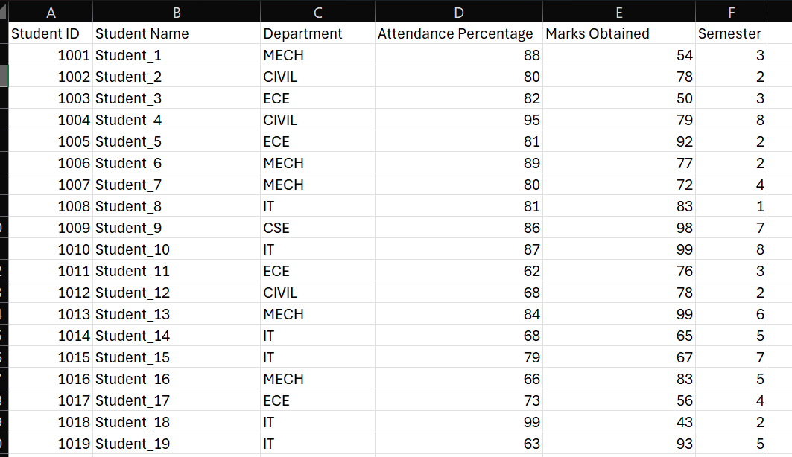

4. Data Exploration
Data exploration was performed to understand the structure and quality of the dataset. The following operations were carried out:
- Displayed the first few records of the dataset.
- Examined dataset information and data types.
- Checked for missing values.
- Generated summary statistics for numerical columns.
- Verified data consistency and completeness.
The dataset did not contain missing values and was suitable for analysis.

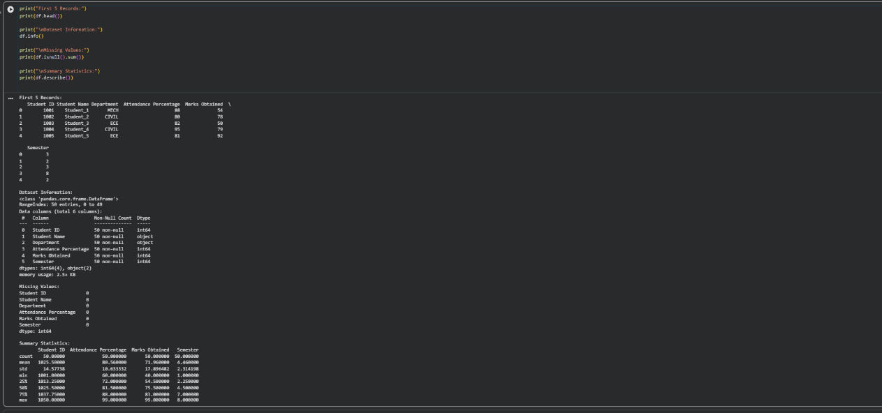
5. Data Analysis
Several analytical operations were performed on the dataset:
Average Marks
The average marks of students were calculated to understand overall academic performance.
Highest and Lowest Marks
The maximum and minimum marks obtained by students were identified.
Department-wise Performance Analysis
Average marks were calculated for each department to compare academic performance across departments.
Attendance vs Marks Analysis
The relationship between attendance percentage and marks obtained was examined to determine whether attendance influences performance.
Top 10 Performing Students
The top 10 students were identified based on marks obtained.
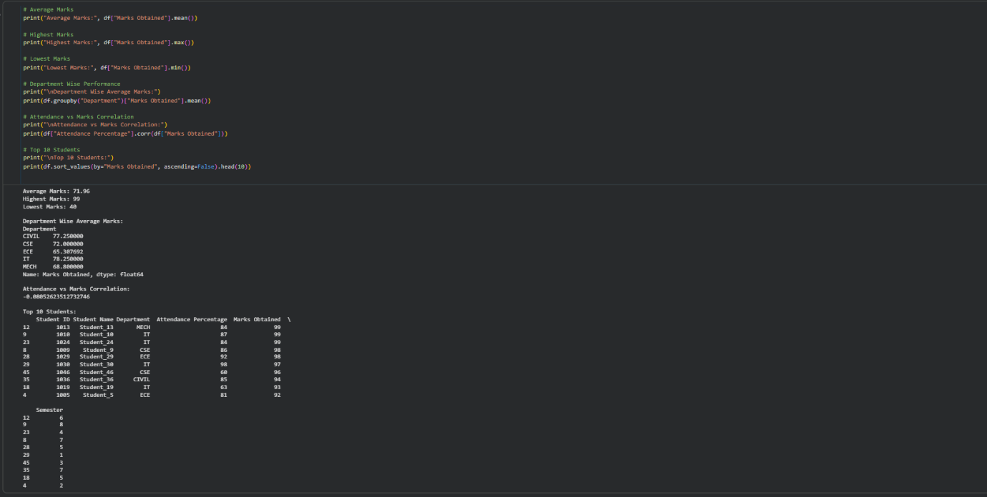

6. Data Visualization
Different charts were created to visualize the dataset and make the analysis easier to understand.

Bar Chart
A bar chart was created to display department-wise average marks.
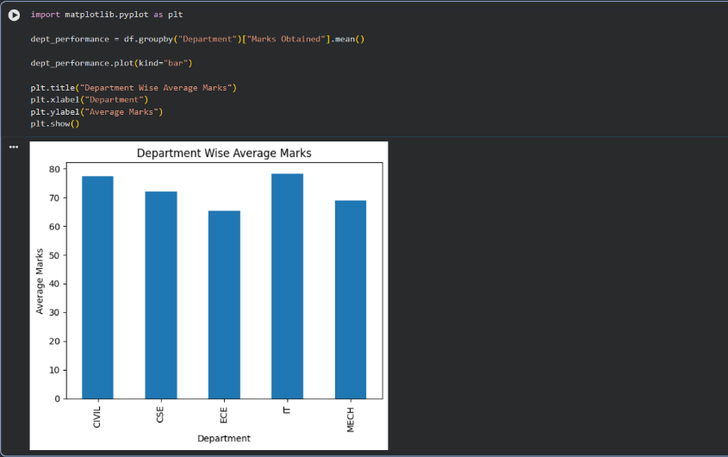
Pie Chart
A pie chart was used to show the distribution of students across departments.
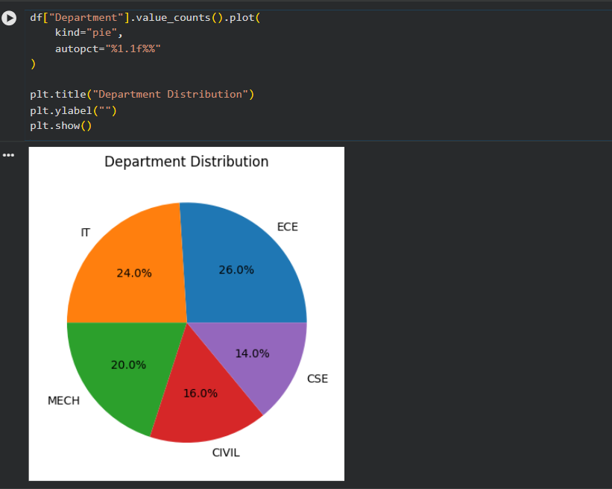
Histogram
A histogram was generated to analyze the distribution of marks among students.
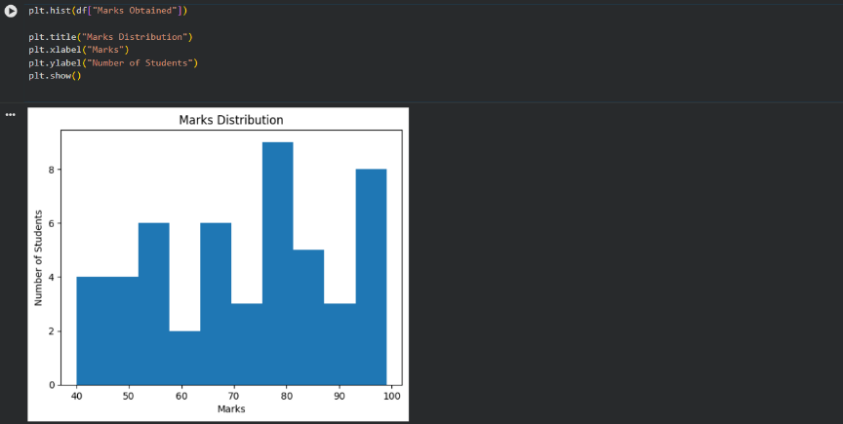
Line Chart
A line chart was used to visualize the relationship between attendance percentage and marks obtained.
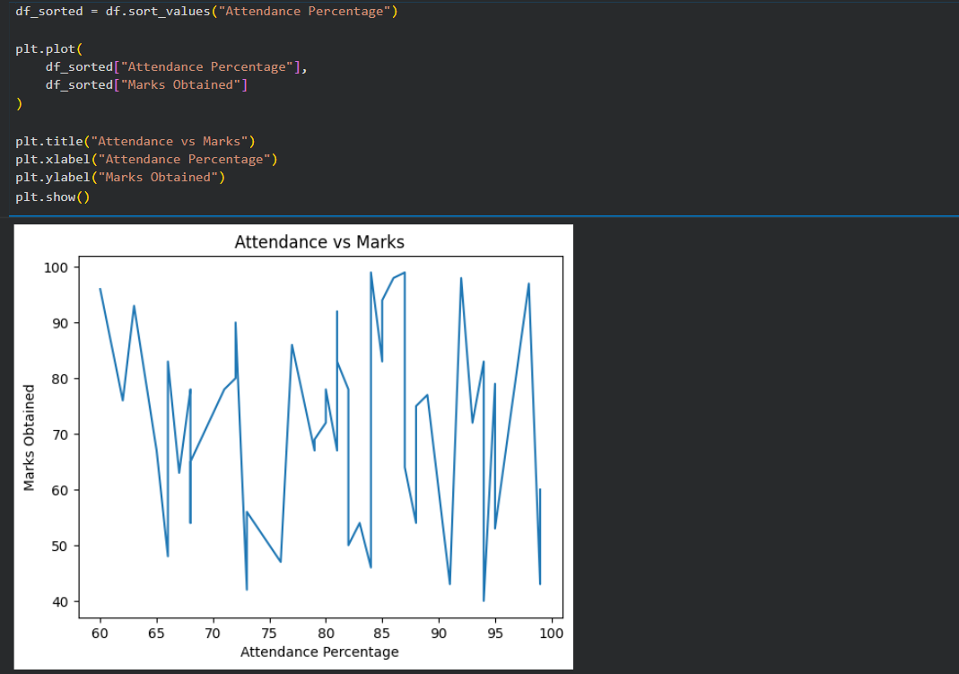

7. Key Insights
- Student performance varied across different departments.
- Students with higher attendance generally tended to achieve better marks.
- The top-performing students scored significantly above the class average.
- Most students scored within a moderate marks range as observed from the histogram.
- Department-wise analysis helped identify differences in academic performance among departments.

8. Conclusion
The Student Performance Analysis project successfully demonstrated the use of Python for data analysis and visualization. By applying various analytical techniques, meaningful insights were obtained regarding student performance, attendance patterns, and departmental comparisons. The project highlights how data analytics can be used to support educational decision-making and evaluate academic outcomes effectively.

